Computer Networks Assignment Spring-25

- How does a switch update its MAC address table when a new host is connected and starts communicating? Explain the learning and aging process.
- What is fast retransmit in TCP? How does it help improve the efficiency of reliable data transfer?
- Explain how ARP works within a local network when a host wants to communicate with a device that is in the same subnet but whose MAC address is unknown.
- Fill up the Source IP, Destination IP and corresponding port number for the packet 2, 3 and 4 as shown in the following figure.

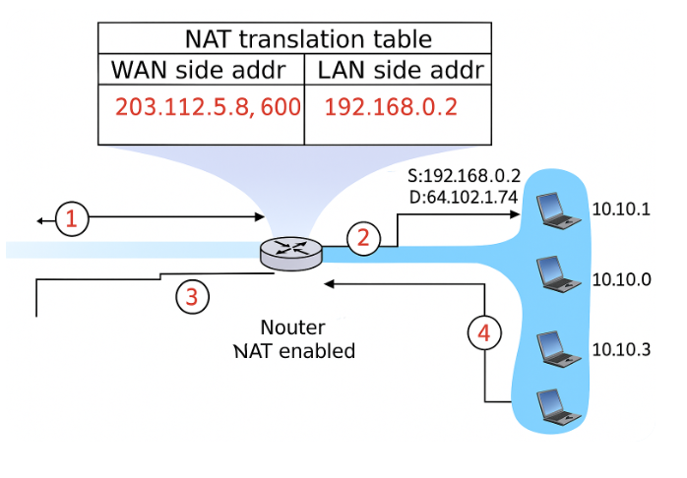
- Calculate the UDP checksum for the binary values 1001100110011001 and 1110000011100000. Show the steps clearly.
- Differentiate between circuit-switched and packet-switched networks. Which is more suitable for real-time communication, and why?
- What is the role of CRC in Ethernet frames? How is it used to detect errors, and what happens when a CRC check fails?
- In a pipelined communication system, what characteristics would identify the use of Selective Repeat protocol? Justify your reasoning with an example.
- A campus network is segmented using VLANs. How can inter-VLAN communication be enabled? Mention any required network devices and their roles.
- Describe how NAT modifies the header of an outgoing packet. What are the implications for inbound packet delivery in static vs. dynamic NAT?
- What is the difference between iterative and recursive DNS query resolution? Describe a scenario where each is used.
- How does CSMA/CA operate in wireless networks to avoid collisions? Why is CSMA/CD not used in Wi-Fi?
- Explain the TCP three-way handshake process in detail. What might go wrong if one of the messages is lost?
- What is fragmentation in IP, and how do routers and hosts handle fragmented packets during transmission and reassembly?
- What are the different types of ICMP messages? Give examples of how ICMP is used for both error reporting and network diagnostics.
- Consider the following network topology. Use Dijkstra’s (Link State) algorithm to compute the least-cost path from node A to all other nodes. Clearly show each iteration of the algorithm and list the final shortest path routes from A to all destinations.

